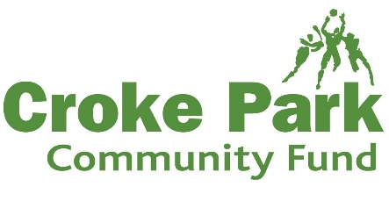
A step by step guide to applying to the Croke Park Community Fund
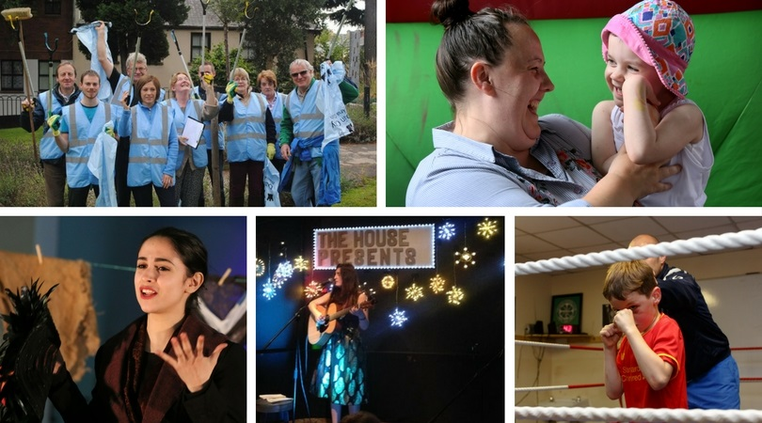
Step 1: Are you eligible?
Check that your organisation is eligible to apply and that your project idea can be considered for support. Ensure you’ve read all of the fund’s terms and conditions before starting your application.
Step 2: Make your application
Complete the application form; applications can be made online or by hand. Assistance completing the application is also available from Croke Park – contact Julianne Savage on 01 865 8607 or jsavage@crokepark.ie Ensure your application is sent in to the stadium in good time – particularly for time sensitive projects.
Step 3: Acknowledgement
You will receive a written acknowledgement within 1 working week of the Community Fund closing date.
Step 4: Evaluation
The independent committee who administer the fund on behalf of Croke Park meet on a quarterly basis to assess each round of applications.
Step 5: Successful Applicants
Successful applicants will be notified in writing within 1 week of the committee meeting taking place confirming funding allocation and next steps.
Step 6: Unsuccessful Applicants
Applicants will also be notified in writing within 1 week of the committee meeting taking place and feedback can be provided to local groups upon request.
Step 7: Get your project started!
You can start your project once you have received confirmation letter from the stadium.
Step 8: Keep in Touch
Keep the stadium updated on your progress and don’t forget, the committee love to be invited along to events & meet with groups that are supported by the Community Fund – make sure to send invitations in good time for time sensitive activities!
Step 9: Public Acknowledgement
All local groups are requested to acknowledge Croke Park’s support through the Community Fund as this helps generate further awareness of the fund amongst other local residents. Specific guidelines on how to do this will be enclosed with your funding letter.
Step 10: Delays
Make sure to get in touch with Julianne Savage in Croke Park if for any reason there are unforeseen delays with your project.
Step 11: Finishing your Project
Your project must be completed within 12 months of the date confirming the funding award.
Step 12: Funding
Once the project is complete and you have your receipts and/or invoices in order, please send them along with a short project report and video or photographs of the project into Croke Park for processing. This typically takes 4-5 weeks before payment is issued by cheques. Payment of the funding can be drawn down in 2 tranches if needed.
Application Form 2018
- Please type or use BLOCK CAPITALS if filling in this form by hand – illegible forms will be returned to applicant for completion
- All questions must be answered. Incomplete application forms will be returned to applicant for completion
- If you need assistance completing the form, please contact Julianne Savage in Croke Park on 01-865 8607 or jsavage@crokepark.ie

1. APPLICANT ORGANISATION/GROUP DETAILS
Name of Organisation/Group: Click or tap here to enter text.
Address: Click or tap here to enter text.
Telephone: Click or tap here to enter text. Email: Click or tap here to enter text.
Chairperson (if applicable): Click or tap here to enter text.
Telephone: Click or tap here to enter text. Email: Click or tap here to enter text.
Treasurer (if applicable): Click or tap here to enter text.
Telephone: Click or tap here to enter text. Email: Click or tap here to enter text.

2. PROVIDE AN OVERVIEW OF YOUR ORGANISATION/GROUP & ITS KEY ACTIVITIES
Click or tap here to enter text.
3. PLEASE INDICATE THE NATURE OF YOUR STRUCTURE:
Voluntary Committee with Constitution ☐
Company Limited by Guarantee ☐
Trust ☐
Other. If other, please specify Click or tap here to enter text.
4. CONTACT DETAILS FOR ALL CORRESPONDENCE IF DIFFERENT TO ABOVE
Name: Click or tap here to enter text.
Address Click or tap here to enter text.
Telephone: Click or tap here to enter text. Email: Click or tap here to enter text.
Position in Organisation/Group: Click or tap here to enter text.
5. HOW DO YOU FUND EXISTING ACTIVITIES?
Click or tap here to enter text.
6. DESCRIBE IN DETAIL THE SPECIFIC PROJECT FOR WHICH YOU ARE SEEKING FUNDS. PLEASE PROVIDE AS MUCH DETAIL AND INFORMATION AS POSSIBLE TO ASSIST US IN UNDERSTANDING YOUR PROPOSAL:
Click or tap here to enter text.
7. GIVE SPECIFC DETAILS OF WHO THE MAIN BENEFICIARIES LIVING IN THE STADIUM’S COMMUNITY AREA OF THIS PROJECT WILL BE:
Click or tap here to enter text.
8. ITEMISE THE COST ELEMENTS (Attach as much additional documentation as will clarify):
- WHERE THE PROPOSAL INCLUDES CAPITAL ITEMS, 3 QUOTES MUST BE ATTACHED
- SUPPLIER QUOTES MUST BE PROVIDED FOR ALL COSTS IN EXCESS OF €500

Item | Cost €
Click or tap here to enter text.
Click or tap here to enter text.
Click or tap here to enter text.
Click or tap here to enter text.
Click or tap here to enter text.
Click or tap here to enter text.
Click or tap here to enter text.
Click or tap here to enter text.
Click or tap here to enter text.
Click or tap here to enter text.
Click or tap here to enter text.
Click or tap here to enter text.
Click or tap here to enter text.
Click or tap here to enter text.

TOTAL COSTS: € Click or tap here to enter text.
9. AMOUNT OF GRANT SOUGHT from the CROKE PARK COMMUNITY FUND – no project receives 100% of project costs
AMOUNT OF GRANT SOUGHT: € Click or tap here to enter text.
10. HAS YOUR ORGANISATION APPLIED FOR ANY OTHER FUNDS IN SUPPORT OF THIS SPECIFIC PROJECT? Please Indicate To What Sources, When, And What Outcome.
Click or tap here to enter text.
11. HOW WILL YOU FUND THE BALANCE OF YOUR COSTS?
Click or tap here to enter text.
12. HAS YOUR ORGANISATION PREVIOUSLY APPLIED TO THIS FUND?
YES ☐ NO ☐
- If yes, what years have you previously applied to the fund? Click or tap here to enter text.
- What was the Outcome? Click or tap here to enter text.
13. IF YOUR ORGANISATION HAS SUCCESSFULLY APPLIED TO THE CROKE PARK COMMUNITY FUND IN THE PAST, PLEASE PROVIDE A SHORT REPORT ON HOW THE FUNDING WAS SPENT
Click or tap here to enter text.
APPLICATION CHECKLIST:
USE THE FOLLOWING CHECKLIST TO ENSURE YOU HAVE FULLY COMPLETED THE APPLICATION FORM:
All questions in the application form have been answered ☐
Three quotes have been submitted for any capital item in your costs ☐
Supplier costs have been provided for any item in your costs in excess of €500 ☐
DECLARATION:
On behalf of Click or tap here to enter text. I confirm that I have read and accept the terms and conditions applying to the Croke Park Community Fund 2018. I confirm that I am authorised to make this application on behalf of the organisation/group and that the information given in the application and attachments is true.
Signed: Click or tap here to enter text. Date: Click or tap here to enter text.
Name (block capitals): Click or tap here to enter text.
POSITION IN THE ORGANISATIION/GROUP: Click or tap here to enter text.

CROKE PARK COMMUNITY FUND TERMS AND CONDITIONS 2018

The Community Fund is administered for Croke Park by an independent committee on behalf of the stadium and the following terms and conditions apply:

- Applications are only accepted from bona fide community/resident/voluntary organisations that are based within the stadium’s 1.5km catchment area
- 80% of the project’s beneficiaries must be usually resident within the stadium’s catchment area.
- Applications must be submitted in advance of costs being incurred. The Fund will not consider costs already incurred. Applicants are advised to submit the documentation as early as possible for time-specific projects.
- There are four rounds of funding in 2018. Closing dates for applications for each round of funding in 2018 are as follows:
  - For community projects that must take place between January and March 2018, the closing date for applications is 5pm, Monday, 27 November 2017.

  - For community projects that must take place between April and June 2018, the closing date for applications is 5pm, Friday, 2 February 2018

  - For projects that must take place between July and September 2018, the closing date for applications is July - September 2018 is 5pm, Wednesday 9 May 2018

  - For projects that must take place between October and December 2018, the closing date for applications is 5pm, Wednesday, 29 August 2018

- Applications received after the closing date for any round of funding are not accepted.
- No project will be given 100% of its costs.
- Funding can be applied for any initiative/project/programme/activity/equipment/facility which is a one off. Ongoing costs/overheads/administration costs are not eligible.
- The Community Fund will only consider one application from any organisation/group in each year.
- Approval of funds does not create a precedent that the same or similar applications will receive funds in subsequent years.
- No organisation or group will receive funding for the same event or programme for more than three years. An exception will be made for local voluntary groups seeking support to organise community based events.
- Applications seeking support for the following activities are not eligible for consideration:
  - Activities that have started or have any expenditure incurred before funding is confirmed
  - Applications from private, profit-making, or commercial organisations
  - National charities
  - Projects or activities where there is a clear statutory or public services responsibility (including funding for core school functions & classroom materials)
  - Salary or routine administration costs e.g. rent, utilities, insurance
  - Items that mainly benefit individuals (sports clothing/uniforms etc.), where there is no evidence of wider community engagement
  - Individuals (e.g. for personal sponsorship).
  - Projects promoting religious or political beliefs
- Applications must be submitted on the standard application form for 2018 only, together with requested documents and any other information which will assist the Fund Committee in making their decision. Completed application forms can be posted to Community Fund, Croke Park Stadium, Jones Road, Dublin 3 or emailed to communityfund@crokepark.ie
- All fully completed application forms will be acknowledged and clarification/additional information may be sought.
- Incomplete or poorly completed forms, especially where required documentation is not submitted, will be returned to applicants to re-work. All questions must be completed. If you require assistance with your application please contact Julianne Savage, the Croke Park Community Fund Administrator on 01-865 8607 or jsavage@crokepark.ie
- The Fund Committee may seek to meet with the applicants directly or through representatives/an assessor to more fully understand the application.
- Successful applicants have one year from the date of approval in which to draw down funds in no more than two tranches and based on submission of original receipts only for items included in the application.
- Before funds can be drawn down a report, preferably including photos and/or video, on the project activities and outcomes must be submitted.
- The Fund Committee reserve the right to carry out an audit of expenditure in a reasonable timeframe after the granting of funds.
- Successful applicants may be required to take part in promotional activities undertaken by Croke Park to generate greater awareness of the Fund throughout the Croke Park Community. Any material created for promotional purposes shall be owned by Croke Park.
- Successful applicants must acknowledge the Croke Park Community Fund in their own promotional outreach and communications and the Community Fund logo must be used in a prominent place (and be sized in proportion to the level of the contribution in comparison with other benefactors) on all materials produced in relation to the project. All references must be pre-approved by the Croke Park Community Officer prior to print or publication by email jsavage@crokepark.ie
- For capital projects, a permanent plaque must be displayed in a position agreed with the Fund.
- For events, you must display Community Fund banners which are available from Croke Park and must be returned after the event and prior to the issuing of any funds.
- Failure to comply with these acknowledgement requirements may lead to a reduction in, or withdrawal of, funds.
- Canvassing by applicants will automatically result in their application being rejected.
- The Fund Committee’s decision is final.

